**Write a vision for your program:**

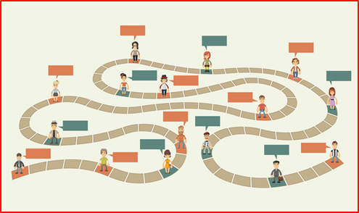

What do you want your customer to “**think**” as they experience your service?

How do you want the customer to “**feel**” about their experience with the services?

**Who is Your Customer?**





**(Very Abbreviated) Customer Journey Map:**

**Touch Points:**



Emotion:

**Thoughts:**



**1.** __________________________  **4.** __________________________

**2.** __________________________ **5.** __________________________

**3.** __________________________

List your

pain points**:**

**Set Priorities**



Which pain point is a high priority to fix?

_______________________________________________________

Select **one**

painpoint

_______________________________________________________

**Develop Solutions**

Review customer thoughts, analyze the problems based on the impacts, and brainstorm possible solutions.

|  |  |
| --- | --- |
| **Customer Thoughts:** |  |
| **Analysis of the Problem:** |  |
| **Solutions:** |  |

**Experimentation**Which solutions will you move forward with? Create hypothesis statement for each of the concepts that you want to pursue:

|  |  |
| --- | --- |
| **Hypothesis Template:** | We believe that **[SOLUTION]** will likely result in **[DESIRED OUTCOME]**.We will know that when **[RESULT/MEASURABLE IMPACT]**. |

We believe that… ___________________________________________________________________  
  
__________________________________________________________________________________

__________________________________________________________________________________

__________________________________________________________________________________

______